LVPEI, other non-governmental entities to evolve alternate healthcare model
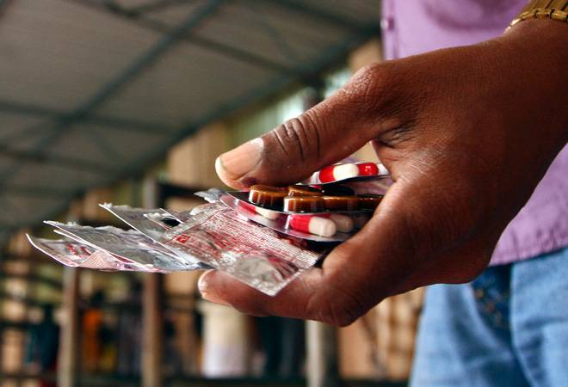

In an attempt towards creating an alternate model of healthcare, which is strong at primary and secondary level but still not-for-profit, a newly formed think tank under LVPEI, Dhan Foundation and the Indian School of Business (ISB) held its first meeting in Hyderabad on Tuesday.

The experts discussed the formation of a model that is collaborative with like-minded institutions trying to make an impact across various verticals of healthcare.

Total 10 organisations participated in the meeting, including Doctors for Seva, Fernandez Hospital, NanoHealth Saksham, Ameya Life, DHAN Foundation and LVPEI (LV Prasad Eye Institute) among others.

"The idea is to cross-learn from the eye care model of LVPEI and implement in other areas," said DVR Seshadri, professor at the Indian School of Business. Seshadri is also working on a book on the LVPEI model. Explaining the LVPEI model, GN Rao, chairman of LVPEI, said it was focused on economically disadvantaged groups in rural and urban areas with a pyramid style services through its satellite clinics and rural affiliates.

A not-for-profit and non-government eye care institution, LVPEI has a centre for excellence in Hyderabad, three tertiary centres - one each in Bhubaneswar, Visakhapatnam and Vijayawada - and 17 secondary and 171 primary care centres. These centres also cover the rural areas across Telangana, Andhra Pradesh, Odisha and Karnataka.

Rao said the model had worked well for the 30-year-old organisation, and that it could help to take learning to other areas. "No more than 10 to 15 per cent of the problems need to reach the big tertiary hospitals," he said, adding that one does not need "specialists in remote locations" as primary care can be provided with good quality if there are "well-trained paramedics".

The DHAN (Development of Human Action) Foundation, which focuses on livelihood promotion, was represented by its founder MP Vasimalai. In existence since 1997, it has so far impacted 1.65 million poor households across 14 states.

https://www.businesstoday.in/sectors/pharma/lvpei-other-non-governmental-entities-to-evolve-alternate-health-care-model/story/272060.html

